LAB MANUAL

Ethical Hacking Laboratory – Kali Linux Commands and Nmap Scanning

Course Code: Ethical Hacking Laboratory

Software Required: Kali Linux (Latest Version)

Experiment 10: Free, Sort and History Commands
Aim:
To execute and understand the usage of Free, Sort, and History commands in Kali Linux.

Commands:
free
free -h
sort file.txt
sort -r file.txt
history
history 10

Procedure:
- Open Terminal in Kali Linux.
- Execute the free command to view memory usage.
- Create a text file and use the sort command.
- Execute the history command to display previously executed commands.

Sample Output:
$ free -h
Mem: 7.6Gi 3.2Gi 2.1Gi
$ sort file.txt
Apple
Banana
Orange
$ history
1 ls
2 pwd
3 nmap localhost

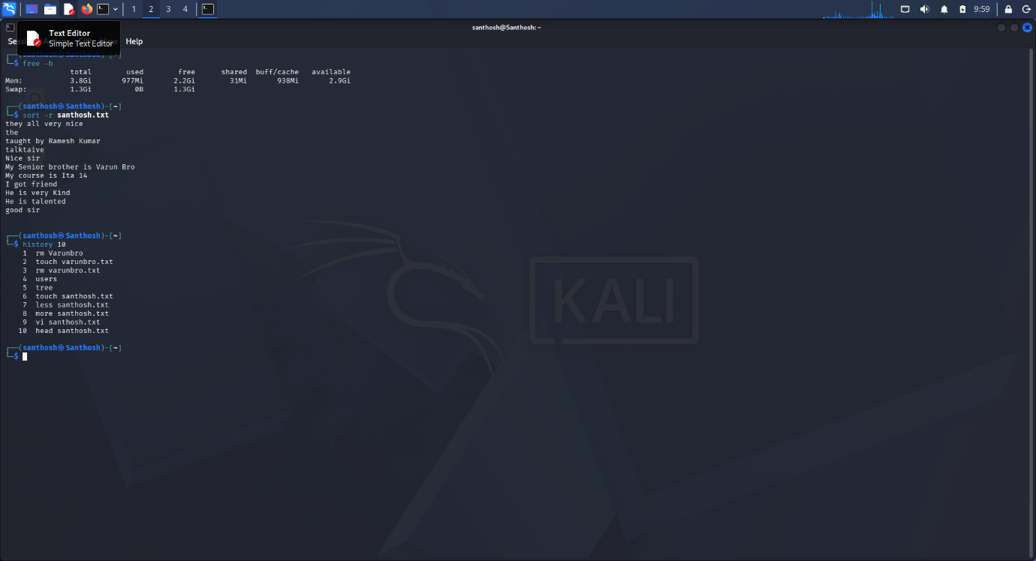

Result:
Successfully executed Free, Sort, and History commands in Kali Linux.

